

Goodmayes Primary School

Head teacher application pack

For September 2020

School visits | Closing Date | Shortlisting | Assessment and Interviews
Tuesday 25th February  Tuesday 3rd March 2020 | Friday 6th March 2020 (Noon) | Tuesday 10th March 2020 | Monday 30th March 2020  Tuesday 31st March 2020



Contents
- Letter from the Chair of Governors (p3)
- Purpose and vision (p4)
- About our school (p5)
- Key Statistics and facts (p6)
- Job description (p7)
- Person Specification (p10)
- Completing your application (p13)
- Important dates and information (p13)


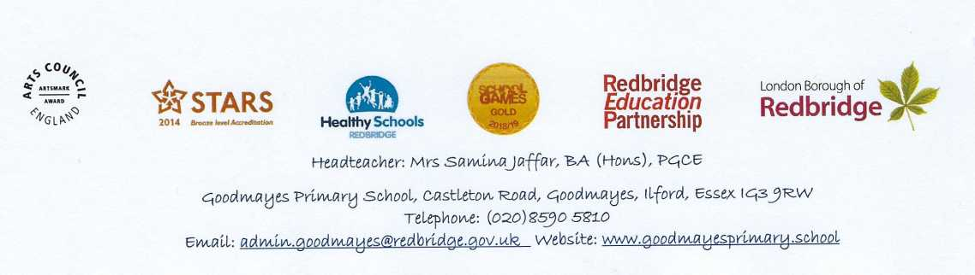
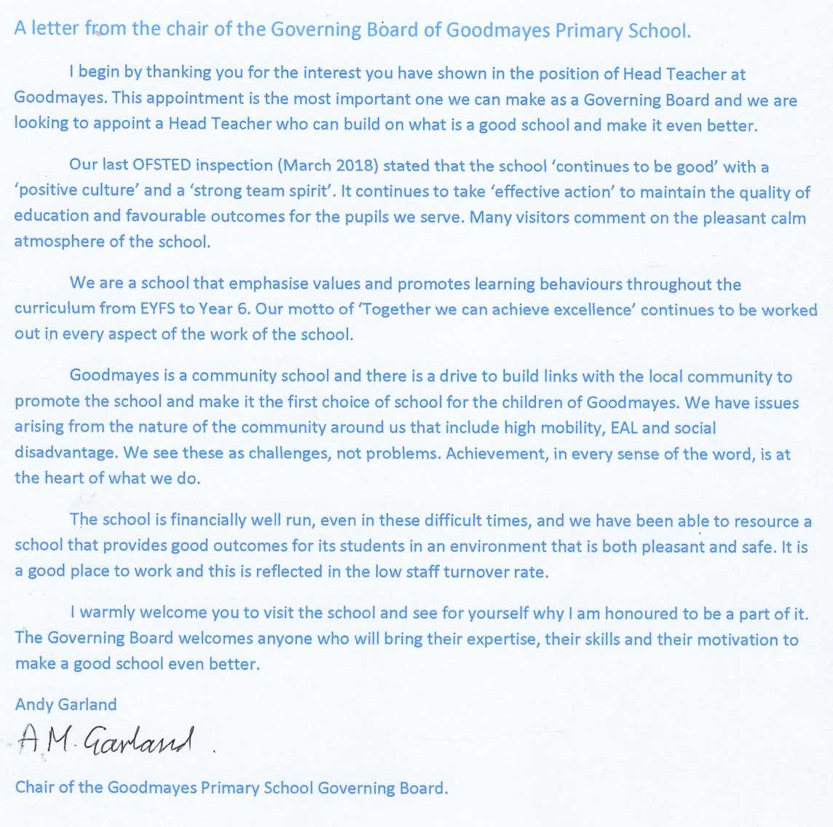

Purpose and Vision.
Our core purpose is to help our pupils be the best they can be. This guides all our policies. We are committed to
Purpose and Vision,
Our core purpose is to help our pupils be the best they can be. This guide all our policies. We are committed to providing excellent educational opportunities through our shared values, as a team and individually.
Our motto is ‘Together we can achieve excellence’.
Our vision for pupils in Goodmayes Primary is to give them opportunities to fulfil their aspirations and achieve the best they can. Our core purpose is helping our pupils be the best they can be. This guides all our policies. We are committed to providing excellent educational opportunities through our shared values, as a team and individually.
- We help our pupils to gain independence, develop lively, enquiring minds and question and argue rationally enabling them to become effective decision makers;
- We challenge our pupils with work that is stimulating, and with targets that are challenging, though realistic.
- We help our pupils gain knowledge, skills and understanding for life in a fast-changing world through curriculum content which is relevant to our pupils' lives and is responsive to their interests;
- We help our pupils to use language, numbers and carryout scientific enquiries in order to help them to use and apply what they have learnt in everyday situations;
- We inform parents/carers of their children's targets and offer advice on how to help them support their children's learning at home;
- We welcome active participation and feedback from parents and members of the community;
- We constantly review the curriculum and the way we teach it;
- We promote understanding and respect for religious beliefs and moral values and tolerance of all ethnic groups, disability, gender orientation and ways of life through assemblies, RE, PSHE&C, and recognition of various festivals and celebrations;
- We help pupils understand the world in which they live and how groups and nations depend on each other;
- We encourage our children to appreciate human achievements and goals through role models from diverse backgrounds

About Goodmayes Primary School
It is situated in an urban environment in the SE corner of Redbridge, bordering on Barking and Dagenham. It is a well-established school that has served the community for over 100 years. Academic outcomes are good but we also develop the ‘whole child’ through music, stage performances and sport activities.
The school itself comprises a mix of the original and new buildings which are well maintained and provide a pleasant environment in which to work and learn. It is a happy school for both children and staff.
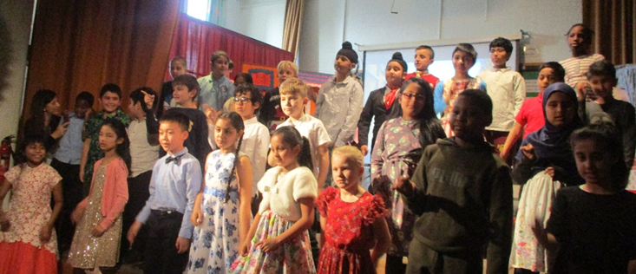
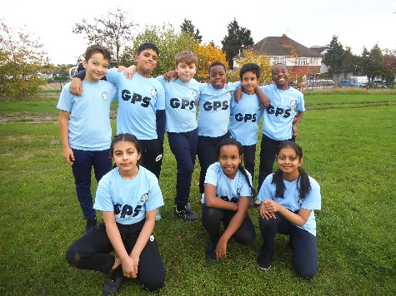
Tag Rugby B Team
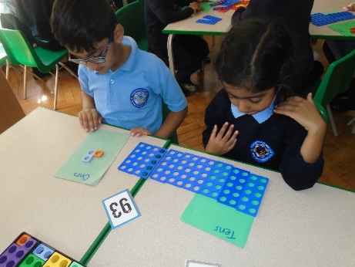
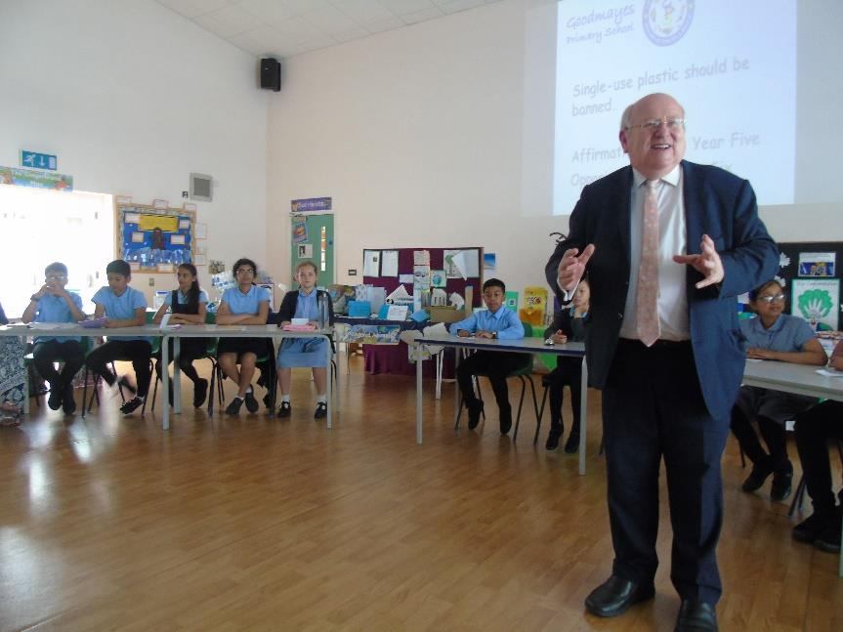
Year 3 stage production.
The local MP visits
Year 4 Production – Cinderella - Rockerfella

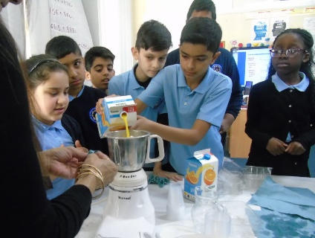
Year 1 pupils partitioning using Numicon

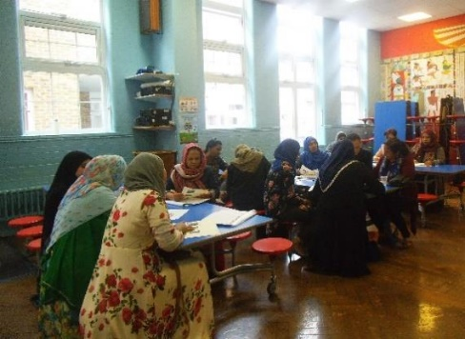
Year 6 Pupils – Making smoothies using ratios in Maths

Parents involved in the English for Everyday project

Key Facts and statistics
Address: Castleton Road, Goodmayes Essex IG3 9RW
Telephone: 020 8590 5810
Email address: admin.goodmayes@redbridge.gov.uk
Website: https://goodmayesprimary.school
Current school figures are:
- Total number of full-time pupils = 676 (Boys = 51.5%, Girls 48.5%)
- Part time (nursery) = 51
- The school is 3 form entry
- The school is 99% full (Capacity= 682)
- Percentage of EAL students = 85.2%
- Percentage minority ethnic = 96.9%
- Number of SEND pupils = 55 (10 of whom have an EHCP)
- Mobility (2018-2019) = 29 % - students leaving and joining
- Teaching standards (Autumn 2019)
Outstanding 6 (22%), Good 21 (78%), Require improvement 0%
- Overall attendance for academic year 2018/19 was 95.48%.
- Free School Meals = 87 (13%)
- Pupil Premium (2019- 2020) = £167 000
- Sports Premium (2019 - 2020) = £26 400
- It is a Community School
- Local Authority Maintained school - Group 4 (URN 102807)
- The school runs from Nursery through to Year 6
- The latest OFSTED (March 2018) found ‘the school continues to be good’. (See the website for the whole report.)
- The school has a uniform policy.

Job description/Key responsibilities
Main purpose of the role of Head teacher

The Head teacher has the overall responsibility for providing leadership and promoting the highest possible standards in order to secure the success and continuous improvement of the school. The Head teacher will:

- Formulate and champion the aims and objectives of the school and provide overall strategic leadership. This will be with involvement from staff and the governors and underpinned by sound financial planning and management
- Build on the School’s vision and ethos and continue to set standards and expectations for high academic achievement and maximise potential for all in our community.
- Create an environment where all children and staff know that their well-being is important and that they are valued members of our school community.
- Establish policies and procedures for securing these objectives and monitor progress towards achieving them, especially in safeguarding and promoting the welfare of children
- Manage staff and resources to that end.
- Lead by example and model best practice regarding professional conduct, work load and personal development.
- Be a role model for all in our community.

The appointment is subject to the current conditions of employment of Headteachers, contained in the School Teachers' Pay and Conditions documents, the School Standards Framework Act 1998 and all other current education, employment and health and safety legislation.
The duties and responsibilities
The Governors of Goodmayes Primary have used the domains and characteristics expected of all head teachers in the National Standards of Excellence for Head teachers but adjusted them where required to reflect the context of our school.
The National Standards of Excellence for Head teachers are set out in four domains:
Qualities and knowledge
Pupils and staff
Systems and process
The self-improving school system
Within each domain there are six key characteristics expected of all Head Teachers; some of
these have been tailored to provide a description of the role at Goodmayes Primary School.
Qualities and knowledge
- Hold and articulate clear values and moral purpose, focused on providing a world class education for the pupils we serve.
- Demonstrate optimistic personal behaviour, positive relationships and attitudes towards our pupils and staff, and towards parents, governors and members of the local community.
- Lead by example - with integrity, creativity, resilience and clarity - drawing on their own scholarship, expertise and skills, and that of those around them.
- Sustain wide, current knowledge and understanding of education and school systems locally, nationally and globally and pursue continuous professional development.
- Work with political and financial astuteness, within a clear set of principles centred on the school's vision, ably translating local and national policy into the school's context.
- Communicate compellingly the school's vision and drive the strategic leadership, empowering all pupils and staff to excel.
Pupils and staff
- Demand ambitious standards for all pupils, overcoming disadvantage and advancing equality, instilling a strong sense of accountability in staff for the impact of their work on pupils' outcomes.
- Secure excellent teaching through an analytical understanding of how pupils learn and of the core features of successful classroom practice and curriculum design, leading to rich curriculum opportunities and pupils' well-being.
- Create an educational climate of mutual support and professional challenge which is open to drawing on and conducting relevant research, sharing the best practice of others, both within our school and in other schools and organisations locally, nationally and internationally, and developing skills and subject knowledge through sustained professional development.
- Sustain and further develop an ethos within which all staff are motivated and supported to develop their own skills and subject knowledge, and to support each other.
- Identify emerging talents, coaching current and aspiring leaders in a climate where excellence is the standard, leading to clear succession planning.
- Hold all staff to account for their conduct, pupil outcomes and professional practice.
Systems and process
- Distribute leadership throughout the organisation, forging teams of colleagues who have distinct roles and responsibilities and hold each other to account for their decision making,
- Ensure that the school's systems, organisation and processes are well considered, efficient and fit for purpose, upholding the principles of transparency, integrity and probity.
- Provide a safe, calm and well-ordered environment for all pupils and staff, focused on safeguarding pupils and developing their exemplary behaviour in school and in the wider society.
- Establish rigorous, fair and transparent systems and measures for managing the performance of all staff, addressing any under-performance, supporting staff to improve and valuing excellent practice.
- Welcome strong governance and actively support the governing board to understand its role and deliver its functions effectively - its functions to set school strategy and hold the Head teacher to account for pupil, staff and financial performance.
- Exercise strategic, child centred and curriculum-led financial planning to ensure the equitable deployment of budgets and resources, in the best interests of pupils' achievements and the school's sustainability.

The Self-improving school system
- Create outward-facing schools which work with the Redbridge Educational Partnership, other schools and organisations - in a climate of mutual challenge - to champion best practice and secure excellent achievements for all pupils.
- Develop effective relationships with fellow professionals and colleagues in other public services to improve academic and social outcomes for all pupils.
- Challenge educational orthodoxies in the best interests of achieving excellence, harnessing the findings of well evidenced research to frame self-regulating and self- improving schools.
- Shape the current and future quality of the teaching profession through high quality training and sustained professional development for all staff.
- Model entrepreneurial and innovative approaches to school improvement, leadership and governance, confident of the vital contribution of internal and external accountability.
- Inspire and influence others - within and beyond schools - to believe in the fundamental importance of education in young people's lives and to promote the school values and the value of education.

Person specification Criteria
(Key E = Essential D = Desirable A = Application I = Interview)

Education and Qualifications
1. Qualified Teacher Status |  | E |  | A
2. Assistant or Deputy Head teacher experience |  | E |  | A
3. Proven commitment to and evidence of continuous development in leadership and management and including safeguarding |  | E |  | A
4. Higher qualification in education and/or management |  | E |  | A
Experience

- Effective senior leadership experience, as a Head Teacher or as an Assistant or Deputy Head, in a primary school |  | E |  | A/I
- Experience of teaching across the primary curriculum |  | E |  | A/I
- Experience of teaching in a school with a multi-ethnic, multi-faith community and socio-economic disadvantage |  | D |  | A/I
- Proven track record of improving outcomes for pupils and diminishing differences in attainment, including for SEND and disadvantaged pupils |  | E |  | A/I
- A proven track record of improving quality of teaching and raising standards. |  | E |  | A/I
- Proven track record of leading school improvement via demonstrable success in articulating, implementing, monitoring and evaluation a plan for School Improvement. |  | E |  | A/I
- Experience of working in the safeguarding of children |  | E |  | A/I
- Experience of and commitment to working closely and collaboratively with the Governing Board to develop and implement a shared vision |  | E |  | A/I
Leadership Capacity

- Has the vision, ambition and ability to think and work strategically and understands the importance of implementing strategies for behaviour for learning and dealing with issues that are barriers to achievement. |  | E |  | A/I
- Can inspire, challenge, motivate and empower all – pupils, staff, parents/carers and governors - to commit fully and engage with the school to enhance pupils’ learning and development |  | E |  | A/I
- The ability to delegate responsibility and accountability |  | E |  | A/I
- Has a thorough understanding of the statutory requirements, frameworks for education and legal framework, which underpin leadership and school management and has the ability to make accurate judgements against agreed criteria |  | E |  | A/I
- Leadership of an area of the curriculum and knowledge of current curriculum initiatives and priorities |  | E |  | A/I
- Evidence of accurate school self-evaluation based on data analysis |  | E |  | A/I
- Can lead fair and transparent systems for performance management of all staff to secure accountability and improve performance. |  | E |  | A/I
- Actively draws on the richness and diversity within the school communities to enhance learning opportunities |  | E |  | A/I
- Commitment to equal opportunities, diversity and inclusion and experience of bringing this to life in the context of school-leadership |  | E |  | A/I
- An understanding of the importance of professional collaboration and working successfully with others within and beyond the school, both educational and community based |  | E |  | A/I
Knowledge and skills

- Can demonstrate highly effective management skills to ensure that resources – financial and otherwise – lead to continuous improvement of teaching and standards of learning for all pupils |  | E |  | A/I
- A thorough knowledge of the national curriculum and commitment to providing an inspiring and rigorous curriculum that deepens knowledge and understanding and enhances personal skills, development and well-being |  | E |  | A/I
- Ability to apply national policy in the local context |  | E |  | A/I
- A thorough and up-to date knowledge of the statutory assessment and the OFSTED inspection frameworks. |  | E |  | A/I
- Political insight, knowledge or national and local trends that could impact on the school and an understanding of the broader educational landscape. |  | E |  | A/I
- Detailed knowledge of current safeguarding statutory guidance and how to implement this through policy and procedures and a culture of vigilance. |  | E |  | A/I
- Financial awareness and the ability to understand, plan and manage the budget in the context of financial benchmarking and best value principles. |  | D |  | A/I
- Has a well-informed commitment to inclusivity and knows how to ensure that the needs of all learners are met. |  | E |  | A/I
- A thorough knowledge of Data Protection Regulations and its implementation in a school setting. |  | E |  | A/I
- An awareness of issues concerning the maintenance of buildings and Health and Safety |  | D |  | A/I
 | Communication and working with people
 | - Developing and sustaining strong relationships, respect and credibility with the governing board, pupils, staff, parents, the wider community and other stakeholders |  | E |  | I
 | Personal Attributes
 | - Excellent interpersonal and communication skills such that they can communicate effectively with self-awareness and social perception |  | E |  | A/I
 | - Receptive to the support and challenge provided by governors and colleagues |  | E |  | A/I
 | - Adaptable to changing circumstances and new ideas and demonstrates creativity and imagination to anticipate and solve problems |  | E |  | A/I
 | - Demonstrates good judgement and possesses the ability to be resilient, robust and calm under pressure |  | E |  | A/I

Completing your application
Application form
Using the standard application form provided (CVs are not accepted), please complete all the aspects of the form fully. Include your full work history with no unexplained gaps since leaving school education. Include all the training you have completed, particular those in recent years, that are relevant for headship.
Person specification and personal statement
When writing your response, it is really important that you address each of the requirements in the person specification. Ensure to evidence additional aspects such as training and qualifications together with your background and experience within the personal statement. You are to use no more than 3 sides of A4.
References
Please ensure that your referees know of your application and they are able to provide a swift response. Preferred referees are your last two employers and you should provide their official organisation email address for us to contact. One referee is likely to be your last Head teacher or Chair of Governors.
Important dates and information
Pay Range |  | Goodmayes is a Group 4 School  Salary Range L21 – L27  Discretionary Payment for the right candidate
Visit the school |  | Tuesday 25th February 2020 or Tuesday 3rd March at 10 am or 2 pm. To arrange a visit please contact the Heads PA by email  Elaine.Shaw@redbridge.gov.uk
Completed Application Form |  | Karen Mount - kmount4.317@lgflmail.org
Closing date |  | Friday 6th March 2020 (noon)
Short listing |  | Tuesday 10th March 2020
Interviews |  | Monday 30th and Tuesday March 31st at Goodmayes Primary School
Start date |  | September 2020

