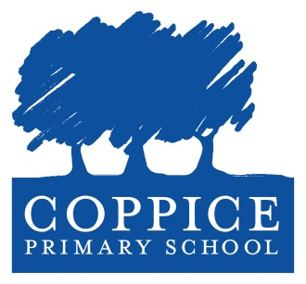
Midday Assistant
LBR1c Point 2: £25,854 (pro rata) (subject to Living wage)
Permanent (subject to satisfactory references and probation period)
Part time: 1 hour 45mins per day (11.30am – 1.15pm)
44.46 weeks per year (term time only – includes INSET days)
Coppice is a vibrant, happy, two form entry primary school with a nursery on the borders of Hainault and Chigwell in the north east corner of the London Borough of Redbridge. Our school was originally built in 1952 and is set within well maintained grounds offering a field, grass, playgrounds, gardens and specialist teaching buildings.
The staff and governors of our school are committed to providing the very best learning opportunities for the children in a safe, secure and friendly community environment.
We are looking to expand our fantastic and dedicated team of midday assistants to provide the children with a positive lunchtime experience.
If you are a happy, friendly, positive and enthusiastic person with the desire to work with children and work as part of a team please complete the attached application form and email to recruitment@coppice.redbridge.sch.uk. Visits to the school are warmly welcomed, please call 020 8708 0740 to make an appointment.
Closing date for applications: 12pm on Monday 30th December 2024
Interviews, observation & Skills Test: Tuesday 7th January 2025
Coppice is committed to safeguarding and promoting the welfare of children and young people and expects all staff to share this commitment. All staff will be subject to references and an enhanced DBS check.
William Torbitt Primary School is an equal opportunities employer. We actively aim to recruit people who reflect our exciting and diverse community.
Please be aware that we may check social media platforms as part of our safer recruitment and selection process.

