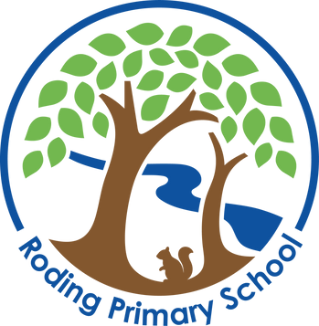
Roding Primary School and Nursery
with Provision for Deaf Children
At Roding, we are ‘Free to Achieve’
Tel: 0208 504 3706
admin@rodingprimary.co.uk www.rodingprimary.co.uk Roding Primary School, Roding Lane North, Woodford Green, IG8 8NP

Headteacher: Ms. M Nwankiti

Safer Recruitment Safeguarding Statement

The staff and governors of Roding Primary School are committed to protecting and safeguarding all our pupils to ensure, as far as is reasonably possible, that they are free from harm.

Before appointment, all staff (teaching and support staff) and volunteers who apply to work at the school are be subject to a rigorous recruitment process to ensure, as far as possible, their suitability to work with children. References will be taken up and candidates will be required to give evidence of their qualifications and details of previous experience and work history. Any gaps or 'loopholes' are investigated further before any interviews take place.

Anyone interviewed for a position at the school will be asked the same questions and their attitudes towards child protection issues will be ascertained by the panel. Motivation for wanting to work with children will also be judged by the interviewing panel.

Safeguarding pupils and child protection are given the highest priority and taken very seriously at Roding Primary School. Any person applying for a position at Roding Primary School will be treated in line with our Equal Opportunities policy but will not be appointed if they do not satisfy our safeguarding guidelines.

Those likely to have unsupervised access to children will also have their details checked by the Disclosure and Barring Service (DBS) and will certainly not be employed if it is considered they are unsuitable to work with children. We also provide regular INSET training on Child protection and the implementation of both our Child Protection and Whistle Blowing Policy.

We strive to create a safe environment for all the children who attend Roding Primary School. Curriculum planning will therefore be instrumental in preparing children for their future responsibilities as adults. Through the curriculum (Collective Worship, Sex and Relationships Education, Personal, Social, Health and Citizenship Education etc) children will be helped to understand what is and is not acceptable behaviour towards them. They will be taught about staying safe from harm and the importance of speaking to a member of staff or other appropriate adult if they have worries or concerns.

The safeguarding and welfare of all children means that there may be times when we consult with colleagues in other agencies if we are concerned about the safety or welfare of a child. This may mean that, on occasions, we may refer our concerns to Social Care Services or the Child Protection Police Unit.

