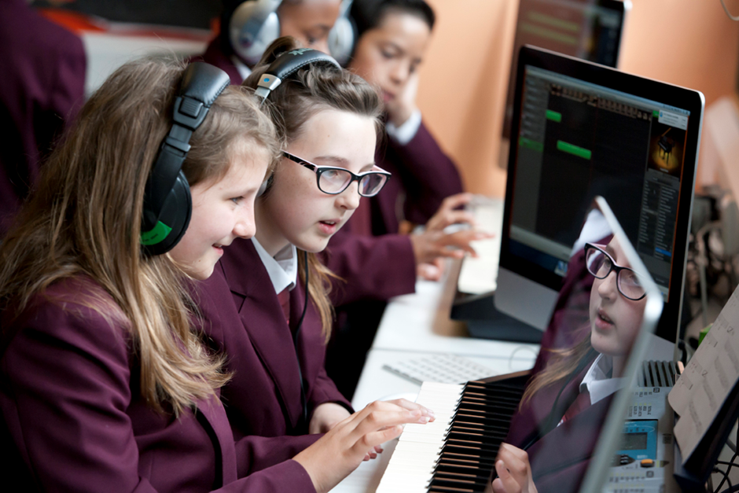

Teacher of Music

November 2016

Dear Colleague,

Thank you for expressing an interest in working with us here at Wanstead High School.

This is a very exciting time to join Wanstead High School. A recent OFSTED report showed that we are “Good” in all areas, and our latest results are the best in the school’s history.

Wanstead High School is a great school; an inclusive, multi-cultural London secondary school of which the community is rightly very proud. This is reflected in our very high numbers of first choices for both Year 7 and Sixth Form applications.

Our goal is to liberate the potential of all our students to aspire, and to provide education with character for all. The school has a committed and creative staff; We provide an innovative, supportive learning environment for all staff, from NQTs, support staff to future leaders within the school and beyond.

We are keen to appoint the right candidate to join us in the next stage of our journey and we hope that you consider applying to be part of our school.

Yours faithfully

Bob Hamlyn
Headteacher

Wanstead High School
Teacher of Music

TITLE OF POST : Teacher of Music
Salary Range : MPS / UPS – Outer London 0/6 fte – 3 days per week
FROM : January 2017 to 31/8/17 (2 terms)

Application Requirements
Along with your application form please write a letter of application, which must:
- address the requirements of the person specification where L is indicated; and,
- outline your suitability for the post.
Your letter should not be longer than two sides of A4 paper font size 11.

Music At Wanstead
What we are looking for:
We are looking for a creative, passionate, committed and dynamic professional to join our vibrant, busy and extremely successful Music department; to enthuse and excite students about Music and enable them to fulfil their full musical potential. The Music team is made up of a Curriculum Team Leader and three further team members. The school has an excellent reputation for music and the school’s leadership, parents and students value the subject very highly.
The successful candidate will be able to teach at Key Stages 3, 4 and 5 and will be fully committed to contributing to the thriving extra-curricular life of the department. We are looking for a well-qualified professional who has the drive to continually develop their pedagogy, musical skills and subject knowledge, and is someone who shares our passion for teaching and learning and determination for our students to achieve excellence.
This post would suit an experienced Music teacher or an NQT equally and offers an outstanding opportunity for the right individual to make a positive difference in a thriving and successful community school with a specialism in the performing arts.
What we offer
The department offers courses in GCSE Music, A-level Music and A-level Music Technology, and a Level 2 BTEC First Award in Music. In the last two academic years, we have achieved a 100% A*-C pass rate (Distinction*-Pass rate for BTEC) for all of these courses with an average GCSE A*-A pass rate of over 55%. The proportion of students opting to take music at KS4 and 5 is much higher than the national average, with around forty students taking music beyond KS3 every year.

Many of our students have continued their studies in music and music technology at universities and conservatoires after leaving the school.
At key stage 3, all students in Years 7, 8 and 9 study music for an hour each week. We focus on developing students’ singing, instrumental, musical leadership, composing, listening, and appraising skills through the curriculum, which includes schemes of work on Samba Drumming, The BBC Ten Pieces, ‘Musical Futures’-style ensemble work, Song-writing and many others. The department has a very inclusive and developmental approach to teaching music and constantly seeks to improve and refine what we offer to students across the school.
The department is very well-equipped, with imacs running Sibelius and Logic in each of the three classrooms, as well as nine practice rooms and a wide range of western and non-western instruments and recording equipment. We work closely with Redbridge Music Service, who provide instrumental and vocal tuition to many of our students in and outside of school. A wide variety of popular extra-curricular activities take place in the department on a weekly basis, including several choirs, a wind band, jazz band, steel pan group, brass group, orchestra and string orchestra. We also work closely with the drama and dance departments and have staged musicals such as ‘Guys and Dolls’ and ‘Oliver’ in recent years. There are several major concerts each year, taking place in our purpose-built theatre and featuring many ensembles, bands and soloists from the school.

Person Specification

L = assessed by application | I = assessed at interview | R = assessed by reference | E = Essential  D = Desirable

Qualifications, knowledge and Experience.
Good degree in the relevant subject or subjects, preferably at 2:1 or above | L |  |  | E
Relevant teaching qualifications | L |  |  | E
Evidence of continuing professional development. | L |  |  | E

Teaching and Learning
High quality teaching skills |  | I | R | E
Evidence of very good examination outcomes for classes taught. | L | I |  | E
A clear understanding and use of Assessment For learning. | L | I |  | E
Understanding of self-review for improvement. |  | I | R | E
The ability to use data effectively to evaluate student teaching group progress and achievement. | L | I | R | D

Personal Qualities and Skills
Evidence of high level communication skills with the ability to communicate effectively with a variety of audiences |  | I | R | E
The ability to build productive professional relationships with students, staff and parents. |  | I | R | E
An ability and evidence of a willingness to empathise and listen, and to be self-critical and reflective. |  | I | R | E
Enthusiasm, hard-work, integrity, creativity, flexibility and resilience. |  | I | R | E
An understanding of and commitment to equal opportunities in its widest sense and a commitment to inclusive education. | L | I | R | E

Safeguarding
Motivation to work with children and young people. |  | I | R | E
The ability to form and maintain appropriate relationships and personal boundaries with children and young people. |  | I | R | E
Emotional resilience in working with challenging behaviours. |  | I | R | E

Teaching & Learning
In accordance with the current DFE Teachers’ Pay and Conditions Document you will:
- Carry out the professional duties of a teacher as circumstances may require under the reasonable direction of the Headteacher.
- Perform, in accordance with any directions, which may reasonably be given to you by the Headteacher from time to time, such particular duties as may reasonably be assigned to you.
- Promote the general progress and well-being of individual pupils and of any class or group of pupils assigned to you.
- To play a full role in the School’s pastoral system as a tutor.
- To contribute fully to the achievement of the aims and ethos of the school.
- To teach Music at KS3, SK4 and KS45.
- To deliver high quality lessons in accordance with the School’s Teaching and Learning policy.
- To develop and prepare appropriate resources for all levels of ability in agreement with departmental and school policies.
- To implement departmental procedures and school policy in respect of marking, assessment and reporting.
- To contribute to the development of courses to meet National Curriculum requirements.
- To contribute to extra-curricular events organized by the department team.
- To help supervise the teaching base and allocated resources, and to undertake the various administrative tasks required.
- To be responsible to the appropriate Curriculum Team Leader.
Safeguarding
To ensure the safety and wellbeing of students in line with:
- The DFE Teachers Pay and Conditions Document.
- The school’s safeguarding policy.

While every effort has been made to explain the main duties and responsibilities of the post, each individual task undertaken may not be identified.

School Vision and Aims
Our Strategic Vision
We will provide high quality education with character: inspiring our young people, keeping them safe, and preparing them fully for life in the modern world.
Strategic Goals of the School
- Further improve the quality of teaching and learning across the school so that all students receive an entitlement to excellence and to education with character
- Establish a curriculum that best meets the needs of every single student
- Develop high quality assessment, tracking and intervention systems to maximise the attainment and achievement of every student
- Ensure all students are safe, healthy and happy, and have the skills and qualities needed to thrive in modern Britain
- Develop leadership opportunities for all members of the school community, and ensure that our staff are fully developed as professionals in order to best meet the school’s vision

School Information
Wanstead High School is a large, improving, multi-ethnic co-educational comprehensive school for students between the ages of eleven and nineteen. We constantly seek to bring about improvement in teaching and learning and in all aspects of school life. Expectations are high both for staff and pupils.

Wanstead High School seeks to enable students to achieve the highest academic standards. Over recent years good examinations results have been achieved at GCSE and ‘A’ Level compared to national standards. In 2016 79% of students gained 5+ A*-C GCSE including Maths and English. Our Progress 8 score puts us in the top 5% of schools in the country. Two thirds of our students stay on to the Sixth Form and the majority of these gain entrance to universities and other centres of Higher Education, and we also recruit a substantial number of post-16 students from the surrounding area.

Our latest OFSTED report, November 2015, rated the school as “Good” in all areas, noting in particular the high quality CPD for our staff.

The school is maintained by the London Borough of Redbridge and is situated in a residential area near Epping Forest, served by the London Transport Underground Central Line and the M11 motorway. It is, therefore, both within easy reach of central London and out-lying areas such as Essex and Hertfordshire.

There are currently approximately 1550 plus students on roll including some 350 students in the Sixth Form. Currently there are 170 teaching and support staff. Eight forms of entry (240 students) are admitted at year seven and there are some 350 plus students in the Sixth Form. The school encompasses a rich social and cultural diversity and 35% of students speak English as an additional language. There are over 35 languages spoken by the students. The school is heavily over-subscribed with some 850 applications for 240 places in Year 7 this year.

All students wear uniform except in the Sixth Form where students are required to wear tailored clothing. After much liaison with 40 linked primary schools (7 main feeders), students join one of nine mixed ability tutor groups and the school seeks to maintain the composition of this and the association with the same tutor throughout the student’s career. The year based pastoral system is central to the discipline and wellbeing of the students. Tutors are led and supported by an experienced team of pastoral heads.

The school has some very good facilities, including a good Sixth Form Centre with state of the art study facilities; ten well equipped Science laboratories and a purpose built theatre, a dance studio and music suite. Considerable refurbishment has taken place over recent years, with work still on-going. The school is well resourced with IT equipment.

The school’s sports facilities are used as a local Leisure Centre, which serves the community in the evening, but which is part of the school during the day. It comprises 4 squash courts, a sports hall, a gymnasium, a multi-purpose sports hall, a fitness training room and a floodlit play area.

